CYBERSECURITY LAB REPORT: SMB FILE SHARING (WINDOWS & KALI)
Student Name: Manmeet Kaur
Date: January 31, 2026
Lab Environment: Windows Server (SMB Server) & Kali Linux (Client)

1. Executive Summary
In this lab, an SMB (Server Message Block) file-sharing environment was configured and tested using Windows as the file server and both Windows and Kali Linux as clients. The lab demonstrated secure file sharing, authentication, permission management, and successful file upload and download operations.

2. Objectives
- Configure SMB file sharing on a Windows system using command-line tools
- Create and manage local users for SMB authentication
- Configure NTFS and share-level permissions
- Access SMB shares from Windows and Kali Linux
- Upload and download files using SMB

3. Lab Environment
Server OS: Windows
Client OS: Kali Linux
Protocol: SMB (TCP Port 445)
Network Type: Private/Bridged Virtual Network

4. Technical Procedures

Phase A: SMB Server Configuration (Windows)
- Created shared directory: C:\SMBShare

mkdir C:\SMBShare

- Created local SMB user using net user command

net user smbuser pass123 /add

- Configured NTFS permissions using icacls

icacls C:\SMBShare /grant smbuser:(OI)(CI)M /T

- Created SMB share using net share command

net share SMBShare=C:\SMBShare /GRANT:smbuser,FULL

- Verified share configuration
net share

Phase B: Accessing SMB from Windows Client
- Accessed SMB share using File Explorer
- Mapped SMB share using command line
- Created and copied files to verify write access
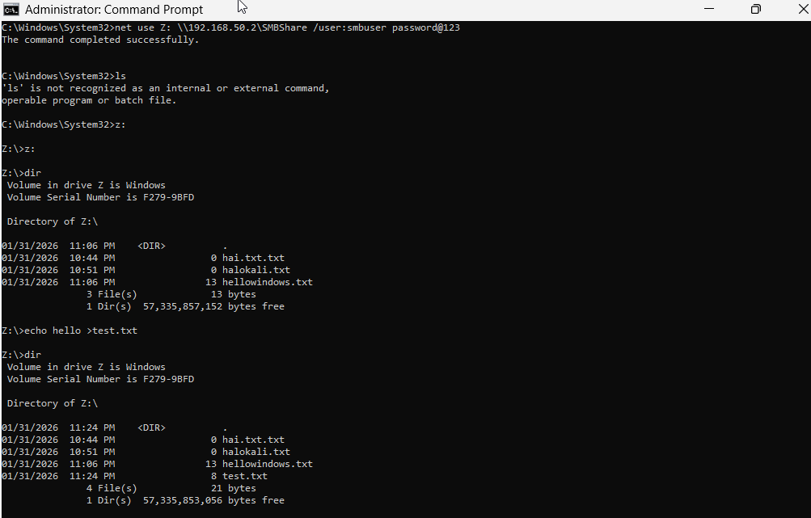

Phase C: Accessing SMB from Kali Linux
- Verified connectivity using ping
- Connected to SMB share using smbclient
- Listed files using ls command
- Downloaded files using get command
- Uploaded files using put command
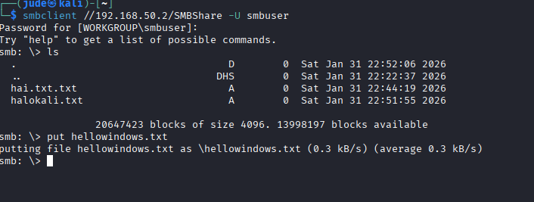

5. Troubleshooting & Observations
- Initial write access issues were caused by missing share-level permissions
- Resolved by recreating the SMB share with FULL access
- Network connectivity issues were resolved by adjusting firewall and adapter settings
- Successful file transfer confirmed correct configuration

6. Conclusion
This lab demonstrated successful SMB file sharing using Windows and Kali Linux. It emphasized the importance of permission management, authentication, and cross-platform interoperability. These skills are essential for system administration and cybersecurity roles.

